**WA LGBTQ+ Survey Report 2025 Social Media Sharing**

Three parts: i. Graphics; ii. Caption; iii. Suggested hashtags

1. ***Graphics:***

Slide 1:

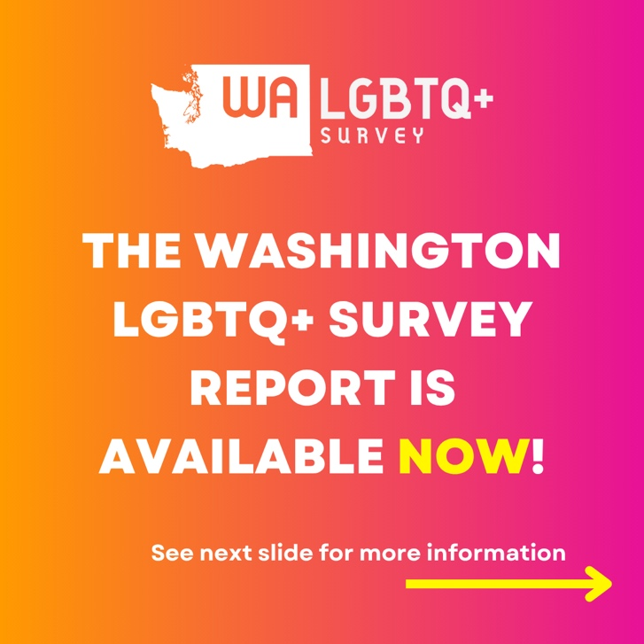

Slide 2:

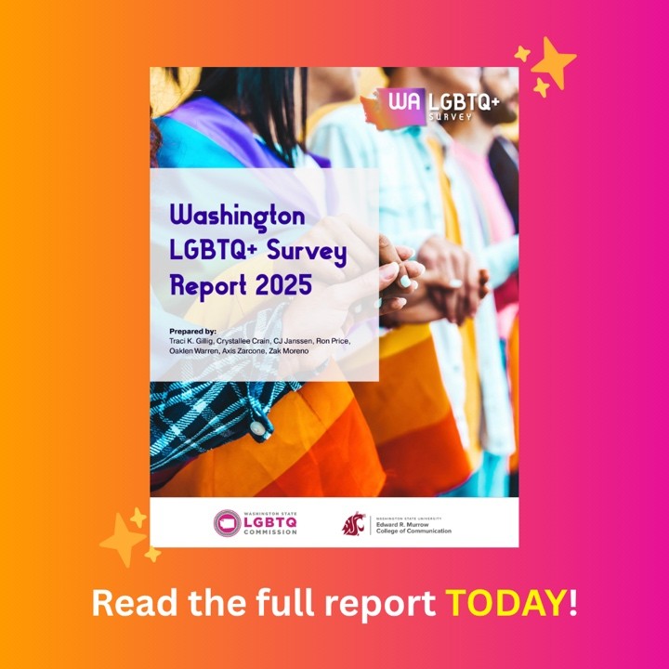

Slide 3:

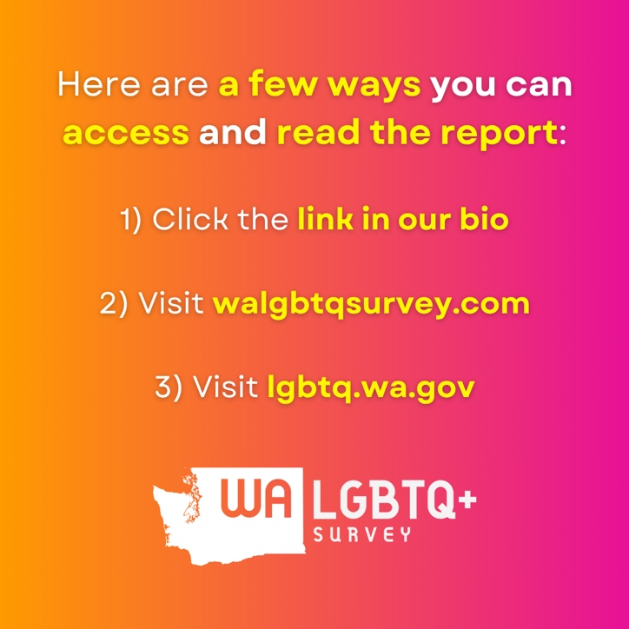

1. ***Suggested caption:***

The Washington LGBTQ+ Survey Report is LIVE! Visit walgbtqsurvey.com or lgbtq.wa.gov to access the report and read the results of this historic statewide effort!

1. ***Suggested hashtags:***

#Pride #PrideMonth #Pride2025 #LGBTQIAPride #lgbtq #lgbtqia #queerjoy #AWashingtonForAllOfUs